# Project Design Phase-I SOLUTION ARCHITECTURE

|  |  |
| --- | --- |
| Date | 19 october 2022 |
| Team ID | PNT2022TMID23664 |
| Project Name | Project – A NOVEL METHOD FOR  HANDWRITTEN DIGIT RECOGINITION |
| Maximum Marks | 4 Marks |

**Solution Architecture:**

Solution architecture is a complex process – with many sub-processes – that bridges

the gap between business pr

blems and technology solutions. Its goals

re to:

* Find the best tech solution to solve existing business problems.
* Describe the structure, characteristics, behaviour, and other aspects of the

software to project sta

* Define features, devel

o

eholders.

pment phases, and solution requirements.

k

* Provide specifications according to which the solution is defined, managed, and delivered.

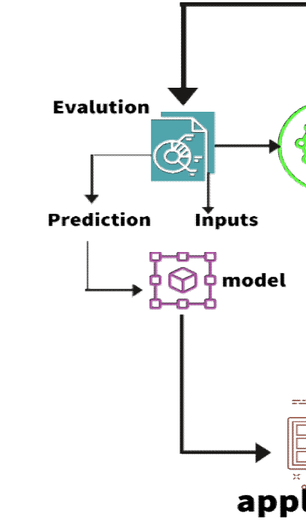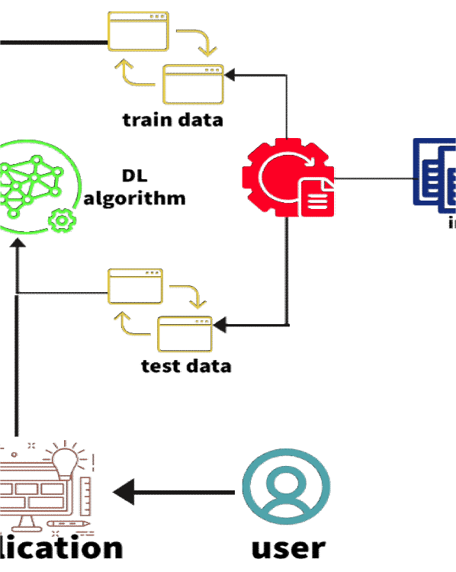

# SOLUTION ARCHITECTURE DIAGRAM:

**` *Architecture -*A Novel Method for Handwritten Digit Recognition System**